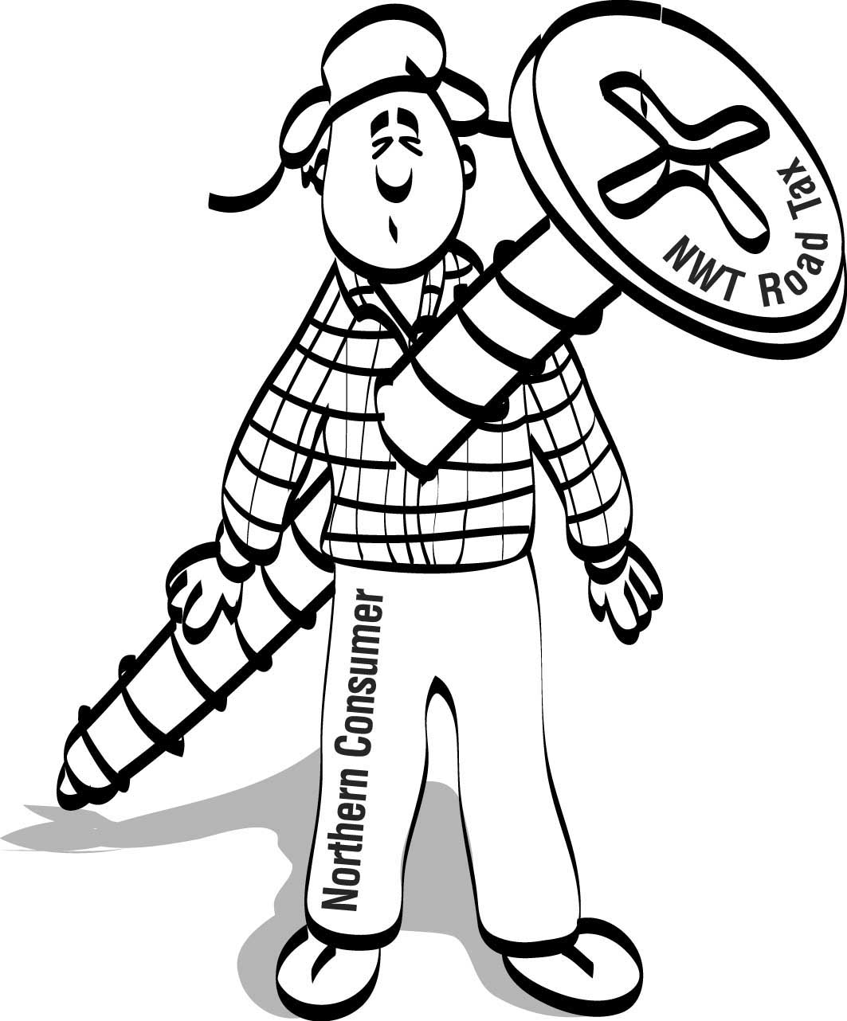

Road Tax Fax

Did you know?

1. The new road Tax will cost the NWT Power Corporation $165,000 annually? That’s about $4.00 for each man, woman and child in the NWT. Not a huge number, but add it to the recent power rate increases and remember it will all come from your pocket.

2. GNWT already has a proposal to fix Highway #3 faster with NO NEW TAX? The proposal from the Yellowknives Dene and Dogrib Rae Band would see highway improvements accelerated from within existing government budgets. The same funding mechanism could be applied to other NWT highways.

3. This Tax is not temporary?
There is no sunset clause in the legislation. Income tax in Canada was introduced as a short-term measure to help win World War I. Governments have a long history of forgetting the temporary part of temporary tax measures.

4. This Tax will devastate recycling efforts?
The Tax will mean an end to cheap backhaul rates that enable cost-effective shipment of recycled materials south.

5. The tax credit proposed by GNWT will not apply to some of the people who need it most?
The tax credit would not apply to those receiving Social Assistance, pensioners who get the Guaranteed Income Supplement and people on Workers Compensation. Yet these people, and other low income earners, will be hit by the higher costs resulting from this Tax.

6. The GNWT still hasn’t said who will actually pay this tax?
The mining industry will pay less than 20%. Some other businesses will also be hit, mainly in our struggling export sector. The rest of the increased cost will be passed on to the consumer – you. Ask the GNWT to tell you who really pays and how it will influence the cost of groceries, heating fuel and other necessities in your community. Remember, even if your community is not on the highway system, you will pay the increased cost of this Tax.

7. The federal government collects $4 billion in fuel taxes in Canada each year yet spends less than $300 million on roads?
Is it reasonable for the 42,000 people in the NWT to pay for the completion of our national highway system?

WE ALL WANT BETTER HIGHWAYS. THIS TAX IS NOT THE WAY TO FINANCE THEM

What Should You Do?

Call or write your MLA now. Tell him or her that you want the government to make its estimates public. Remind him or her that they all were elected on a platform of more open government. Ask what government is doing to study alternatives to a new Tax. Then tell your MLA to

AXE the TAX.

Brought to you by the NWT & Nunavut Chamber of Mines, NWT Chamber of Commerce, Northern Air Transport Association, Fort Smith, Fort Simpson and Yellowknife Chambers of Commerce, NWT Motor Transport Association and a growing coalition of business and consumer groups who oppose this Tax

